Daniel Alvarez

CIS 310 – Project 5

October 16, 2018

Kayak Advertisement Project

Step 1: Add image to Photoshop

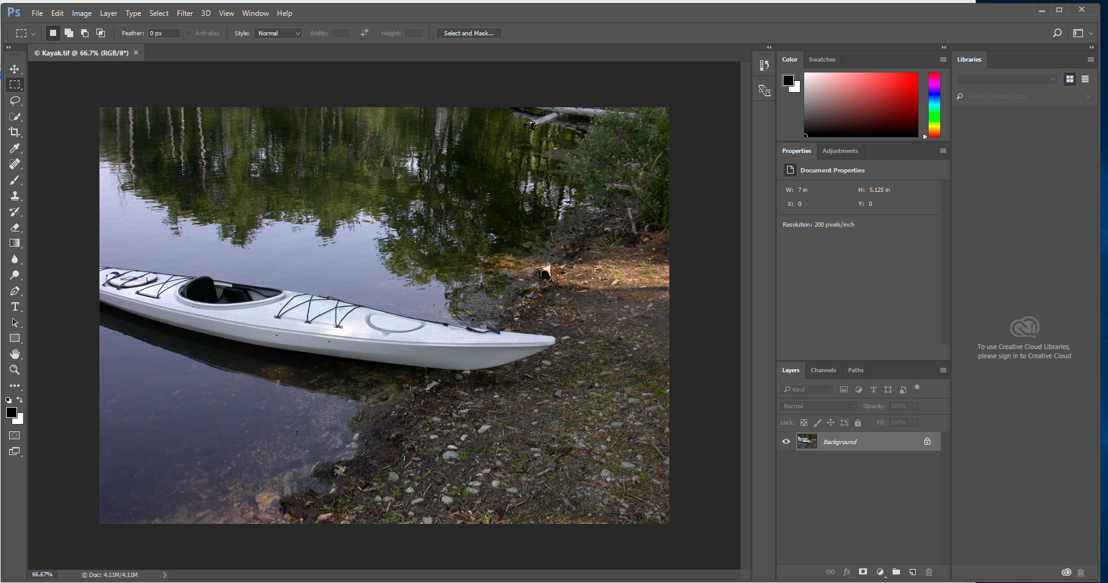

Step 2: Duplicate layer – it is good practice to work on copy to avoid damaging original image (Right-Click-Duplicate Layer)

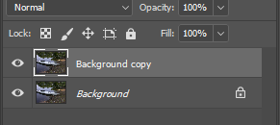

Step 2: Using the ‘quick selection tool’ select the area you want to duplicate/colorize

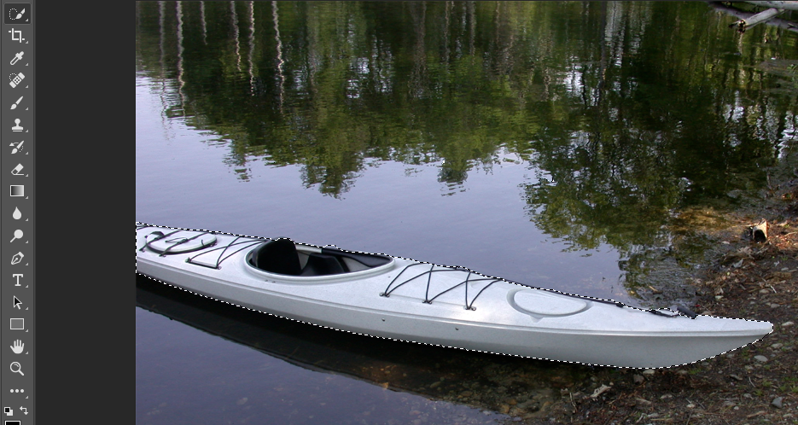

Step 3: Save the selection (from menu: Select-Save Selection) and make a copy (or two in this case, CTR-J) of the selection

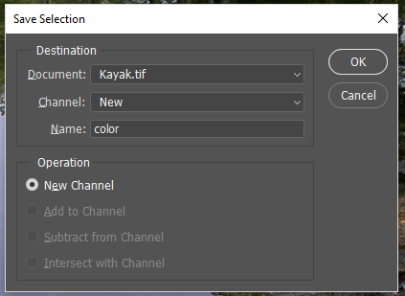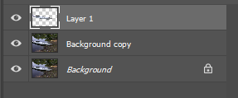

Step 4: Place the layers in the appropriate location in the image using ‘move tool’

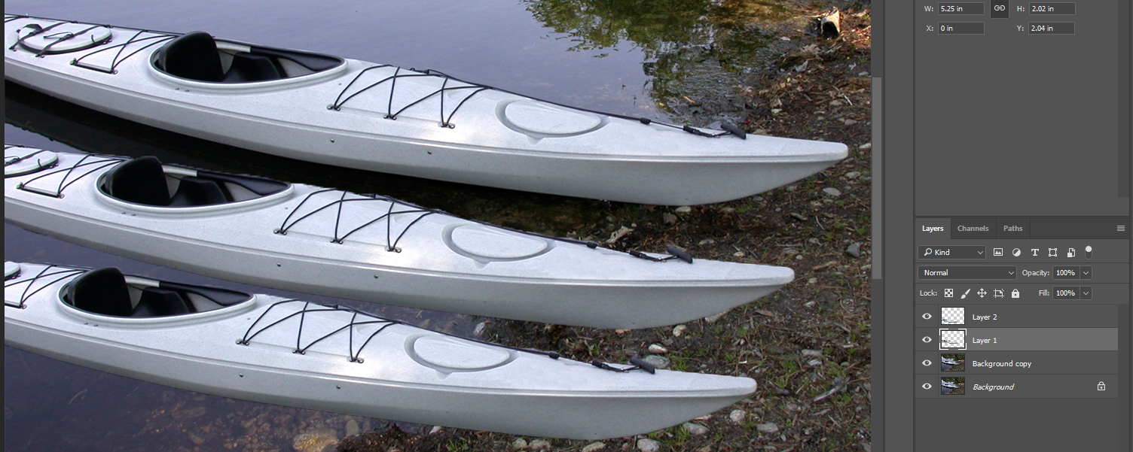

Step 5: Colorize each Kayak according to client specifications (from menu: Image-Adjustments-Hue/Saturation). Ensure to select ‘colorize’. Next to Preset name on the right (gear symbol), save different colors if wanted or needed.

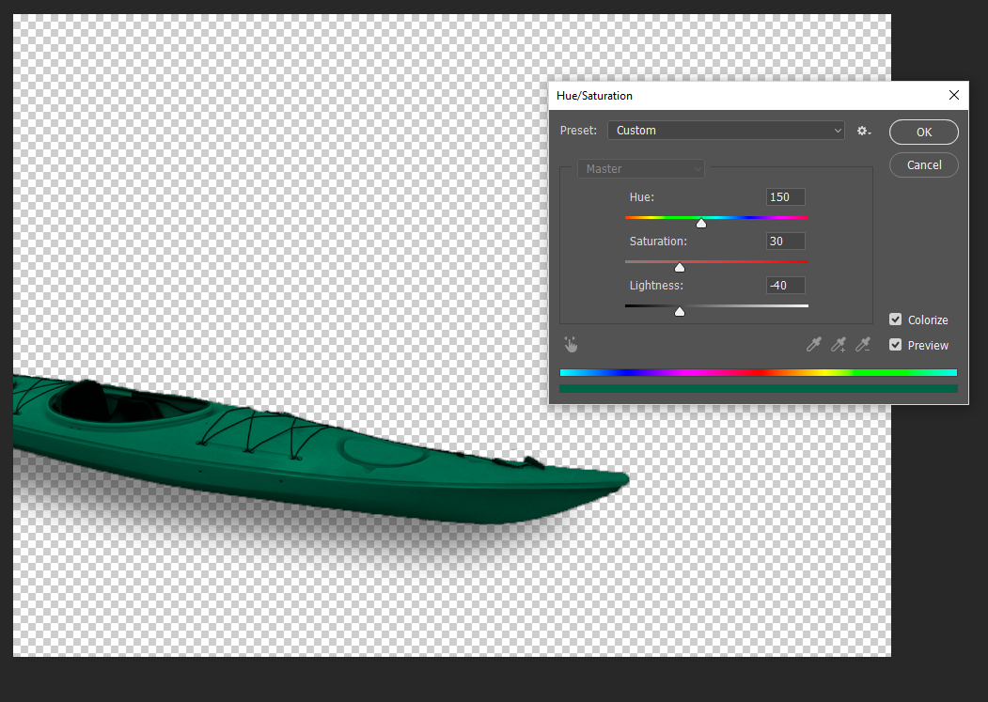

Step 5 continued: Colorize second kayak

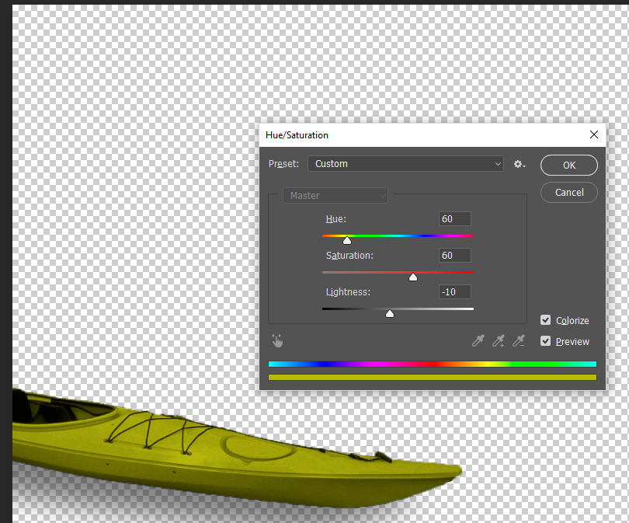

Step 6: Add text with ‘text tool’

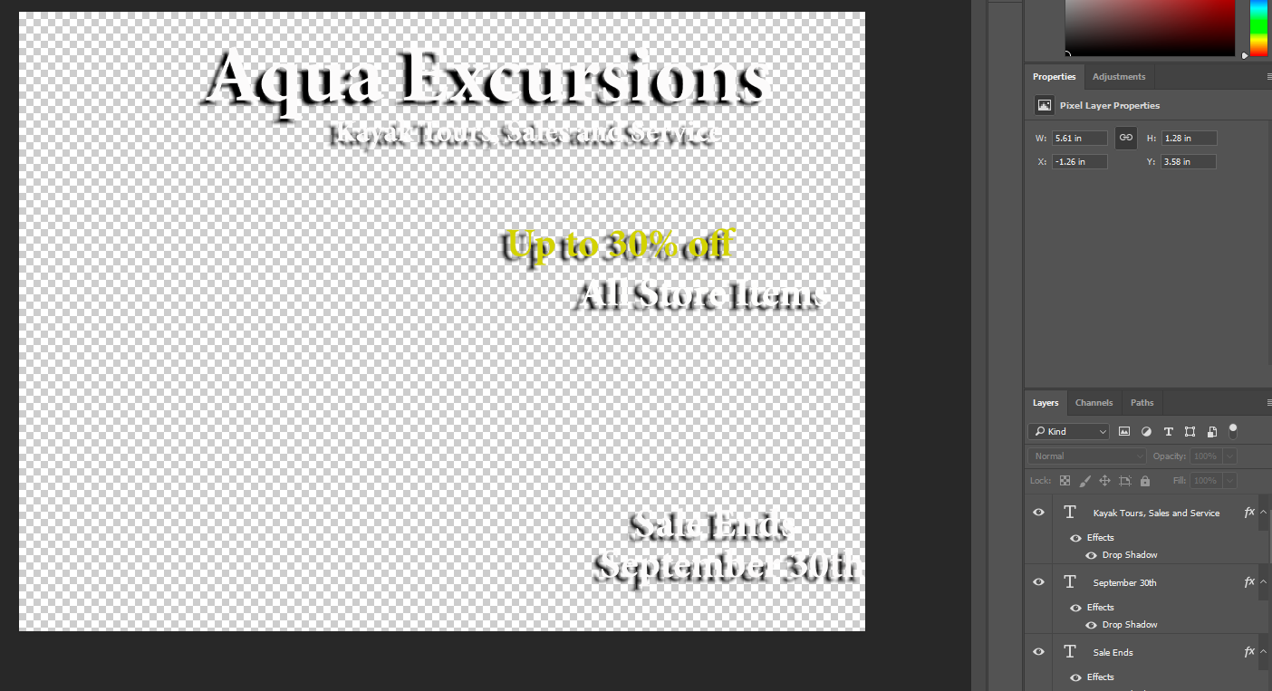

Step 7: Add Drop Shadow effect to kayaks (from Menu: Layer-Layer Style-Drop Shadow) and adjust settings to perfect

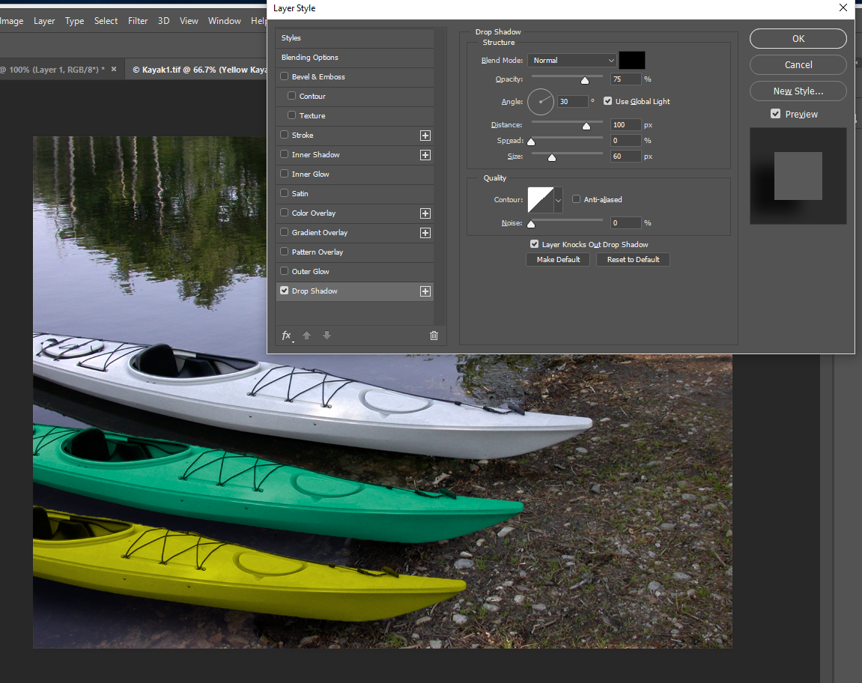

Step 8: Add Drop Shadow effect to text and change color of text (if wanted or needed) 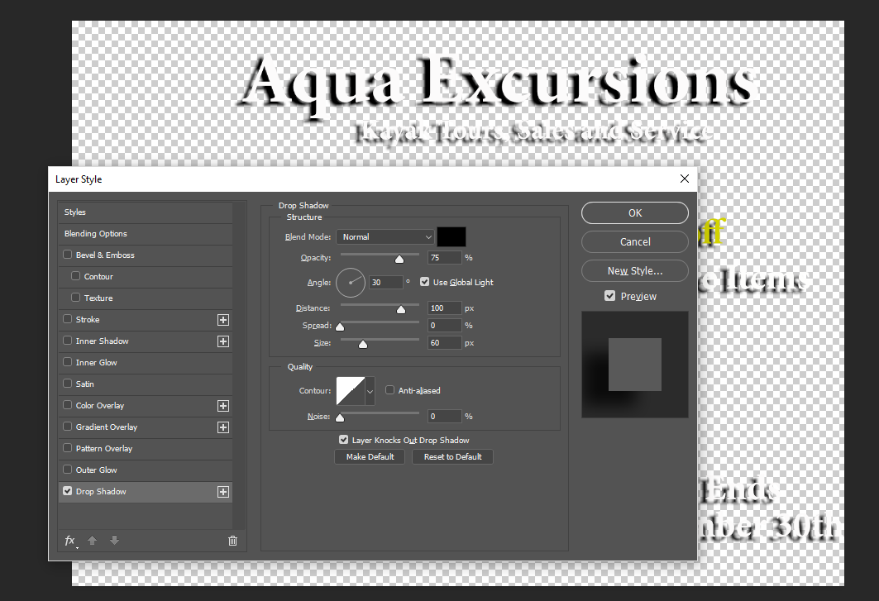

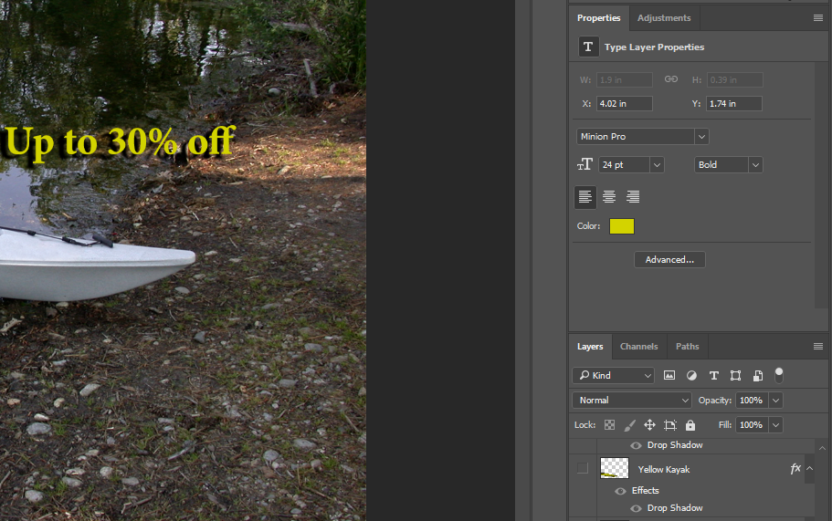

Step 9: Flatten image (Right click original and select ‘Flatten Image’

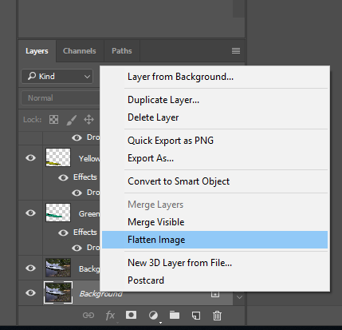

Step 10: ‘Save As’ appropriate file type per client request

